**COMP122 – Winter2017**

**Assigment1 _ Section 06 - Due on February 13th, Monday Midnight**

**Instructions:**

- Each question worth 20 point, total 100

- Assigment1 worth %10 in overall grading

-Due is 1 week from the date it is published.

-Place your SQL under each question along with screen shot of your result

- Upload your word doc into respective Dropbox area

1) Create a report that displays the last name and department number for employee number 176.

2)

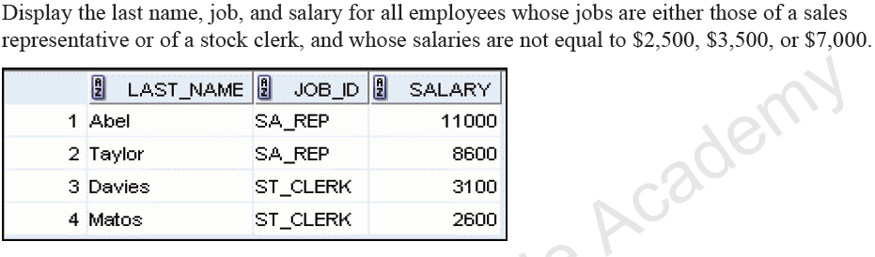

3)

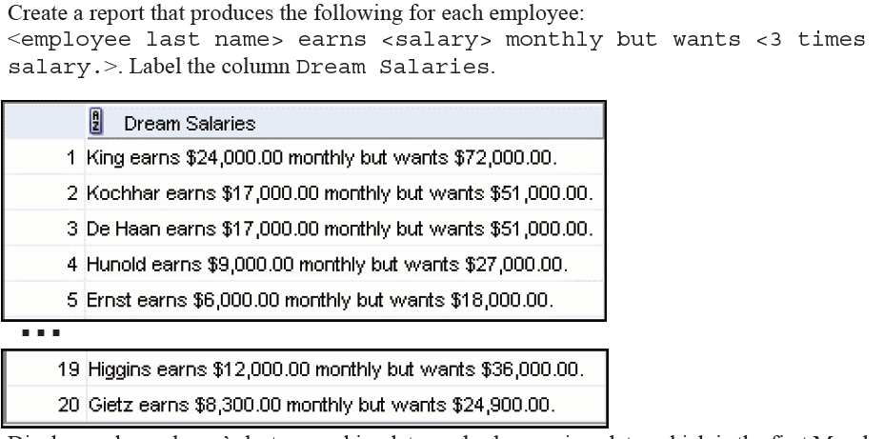

4) Display the last name and department ID of all employees in departments 20 or 50 in

ascending alphabetical order by name.

**5)**

